**UML – Sphere Ski Slop User Log In Functionality**

**Introduction**

Within this document, you will find evidence of the creation of a use case diagram for the log in functionality I have be assigned to for my group work. In order for the system to work correctly the user must be able to log into the system in order for them to interact with the system and book ski-sessions. To ensure that the system works correctly we must first begin designing it using the Unified Modelling Language (UML) and creating the associated documentation so let’s begin.

**Scenario**

**When users arrive for their ski session, a slope operator uses the system to perform the check-in task. The slope operator enters the skier’s user id and the system displays details of the user and any matching booking (including the charge to be made). The slope operator then confirms whether this is the right booking.**

**Use Case Diagram (Log in Functionality)**

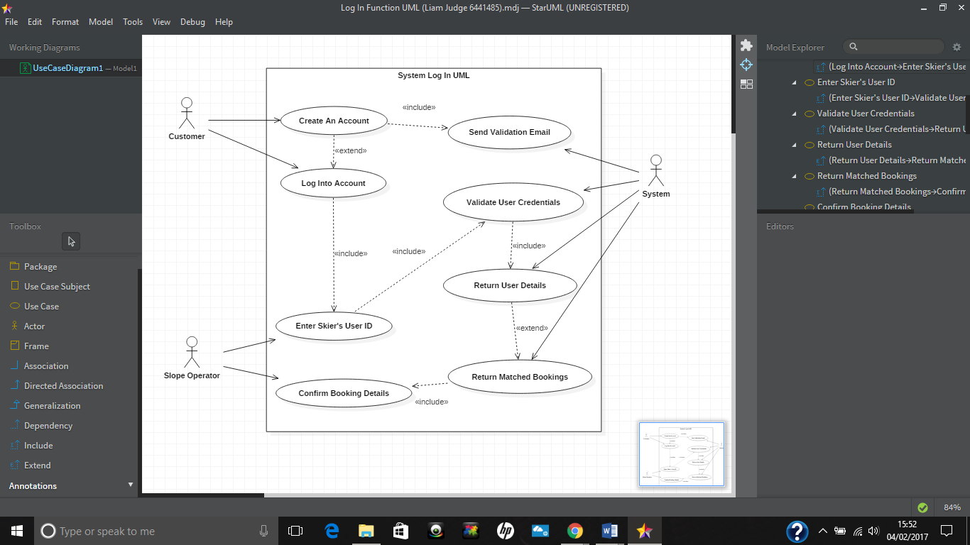

**Use Case Documentation**

|  |  |  |
| --- | --- | --- |
| **Customer** | **Slope Operator** | **System Response** |
|  |  | 00: Display Interface |
| 01: Create an Account |  | 02: Send Account Validation Email |
| 03: Log in To Account | 04: Enter Skier’s User ID | 05: Validate User Credentials |
|  |  | 06: Return User Details |
|  |  | 07: Return Matched Bookings |
| 08: Confirm Booking Details |  |  |
| **Alternate Flow(s): The user may enter the wrong credentials, in which case the system will ask them to re-enter their log in details.**  **The Slope Operator may enter the wrong user ID, in which case the system will return a message asking for the Slope Operator to enter a valid user ID.**  **User may not have any matched bookings, in which case the system will return a message confirming the customer has no booked sessions.** | | |

**Name of Use Case:**

Create an Account

**Pre-Condition(s):**

The user has a valid email address to confirm their registration.

**Post-Condition(s):**

The user has a valid account that they can use to log into the ski slope booking system.

**Purpose:**

To provide a way for the user to interact with the booking system.

**Description:**

The user selects ‘create an account’ on the system screen if they do not already have an account. This will allow new users to interact with the booking system and will provide an account they can use to book future sessions.

**Main Success Scenario:**

1. The user selects ‘create an account’ if they do not already have one.
2. The user enters their name and address.
3. The user enters their contact details such as phone number and email.
4. The user confirms their details.
5. The system validates the user’s information and adds them to the database.

**Alternatives:**

**2.1, 2.3 –** If the user enters invalid information the system will prompt them to renter their information.

**Name of Use Case:**

Log into Account

**Pre-Condition(s):**

The user has already created a valid account.

**Post-Condition(s):**

The user successfully logs into the booking system.

**Purpose:**

To allow the use to log into the system to view, make and cancel bookings.

**Description:**

The user enters the correct log in information (username & password) and clicks the log in button.

**Main Success Scenario:**

**1:** The user enters the correct username and password and successfully logs into the system.

**Alternatives:**

**1.1 –** If the user enters invalid log in information the system will prompt them to renter their information.

**Name of Use Case:**

Send Validation Email.

**Pre-Condition(s):**

The user has signed up to create an account.

**Post-Condition(s):**

The validation email is sent to a valid email account.

**Purpose:**

To prevent people from signing up random people to the system, this will also help to eliminate spam.

**Description:**

The user signs up for an account and a validation email is sent to the associated email for that account.

**Main Success Scenario:**

**1:** The validation email is sent successfully.

**Alternatives:**

**1.1 –** If the email address entered is not valid the user will not be able to sign up to the service.

**Name of Use Case:**

Enter skier’s user ID.

**Pre-Condition(s):**

The user has signed up to the booking system and wants to log into the system.

**Post-Condition(s):**

The slope operator enters the skier’s users ID so they can view the information for that account.

**Purpose:**

To allow the operator to access the customer’s information.

**Description:**

The slope operator enters the users ID to access information for that particular customer.

**Main Success Scenario:**

**1:** The user ID is entered correctly.

**2:** The user’s information is returned by the system.

**Alternatives:**

* 1. **–** If the user ID is entered incorrectly the system will prompt the operator to enter the ID again.

**Name of Use Case:**

Confirm booking details.

**Pre-Condition(s):**

The user has requested information about their booking.

**Post-Condition(s):**

If the user is happy with their booking information it should be confirmed by the Slope Operator.

**Purpose:**

To allow the users to confirm their bookings through the Slope Operator.

**Description:**

The slope operator confirms the customers booking information if the customer is happy with it.

**Main Success Scenario:**

**1:** The user is happy with their booking and it is confirmed by the Slope Operator.

**Alternatives:**

**1.1–** If the customer is not happy with the booking it may be cancelled instead of confirmed.

**Name of Use Case:**

Validate User Credentials.

**Pre-Condition(s):**

The customer has logged into the booking system.

**Post-Condition(s):**

The customer’s username and password is compared to the one in the database.

**Purpose:**

To ensure the customers information is well protected and to allow them to log into the system.

**Description:**

The customers log in details are validated for security purposes.

**Main Success Scenario:**

**1:** The customer enters their username and password.

**2:** The system validates the username and password allowing the customer to log into the system.

**Alternatives:**

**1.2–** If the customer enters the wrong log in details the system will prompt them to try again.

**Name of Use Case:**

Return User Details.

**Pre-Condition(s):**

The customer has logged into the system and the Slope Operator has entered the user ID.

**Post-Condition(s):**

The customer’s information should be displayed on the Slope Operators screen.

**Purpose:**

To allow the Slope Operator to see the customer’s details.

**Description:**

The customer’s information is returned to the Slope Operators screen.

**Main Success Scenario:**

**1:** The customer’s information is returned to the Slope Operator.

**Alternatives:**

**N/A**

**Name of Use Case:**

Return Matched Bookings.

**Pre-Condition(s):**

The customer has made a booking.

**Post-Condition(s):**

The customer’s booking information should be returned to the customer and Slope Operator.

**Purpose:**

To allow the Slope Operator to view the customer’s bookings.

**Description:**

The customer’s bookings are returned to the Slope Operators screen so they can confirm or cancel them.

**Main Success Scenario:**

**1:** The customer’s bookings are found and returned to the screen by the system.

**Alternatives:**

**1.1 –** The customer may not have any bookings, which prompts the system to display a no bookings message.